The Workshop of Permaculture has begun in the Episcopal Church of Cuba
The event is organized by the Missionary Development Program.
In the meeting participate 22 people from all over the country.
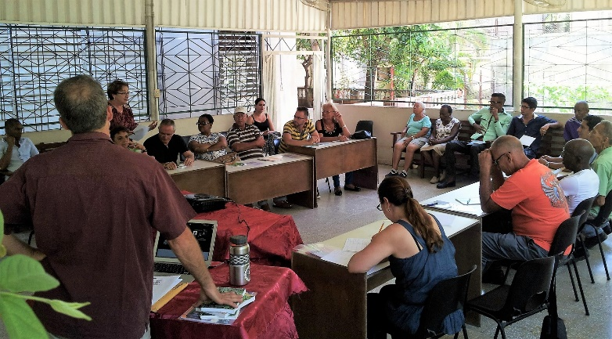
The facilitator is Ron Berezan.
Ron is a certified permaculture teacher and designer through the Permaculture Institute of North America (PINA). He has been an organic gardener for over 30 years and permaculture practioner for over ten years. He is trained in the “Grow Biointensive” organic gardening method at Ecology Action in Willits, California and in Permaculture Design through the Kootenay Permaculture Instituteand the Occidental Arts and Ecology Centre. He is a Master Gardener through the Devonian Botanic Gardens in Edmonton Alberta.
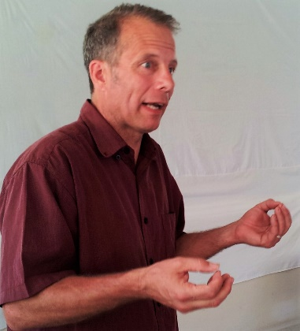
Ron has taught hundreds of permaculture and organic gardening workshops in BC, Alberta, Manitoba, Ontario and the Yukon and has consulted on many permaculture and urban agriculture projects throughout the country. He has a close working relationship with the Antonio Nunez Jimenez Foundation , Association of Cuban Agricultural Technicians and Foresters and now with the Episcopal Church in Cuba and regularly takes groups of Canadians to Cuba for educational tours and permaculture internship opportunities.
Ron writes on a variety of permaculture, urban agriculture and organic gardening themes and has been a regular gardening commentator on CBC Radio and in a range of newspapers and gardening magazines.

