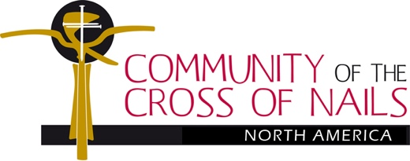 http://www.crossofnails-na.org/
Healing the Wounds of History:
A Community of the Cross of Nails Encounter and Pilgrimage in Cuba
Photos and article By Marilyn W. Peterson, March 9, 2018

On February 1-2, 2018, the Board of the Community of the Cross of Nails-North America (CCN-NA) and CCN leaders from Coventry, England (Canon Dr. Sarah Hills), Germany (Rev. Oliver Schuegraf), and South Africa (Ms. Petrina Pakoe) met in Miami, Florida for the Board’s annual meeting and first leg of its Reconciliation Pilgrimage. On February 3-10, 2018, many on the Board and its distinguished international guests continued to the second leg of its mission in Cuba, organized by the Rev. Mark Pendleton, President of CCN-NA (Christ Church, Exeter, NH) and by Marilyn W. Peterson, Esq., (Holy Trinity, Gainesville, Florida), CCN-NA board member and International Relations Coordinator for the Bishop of Cuba.
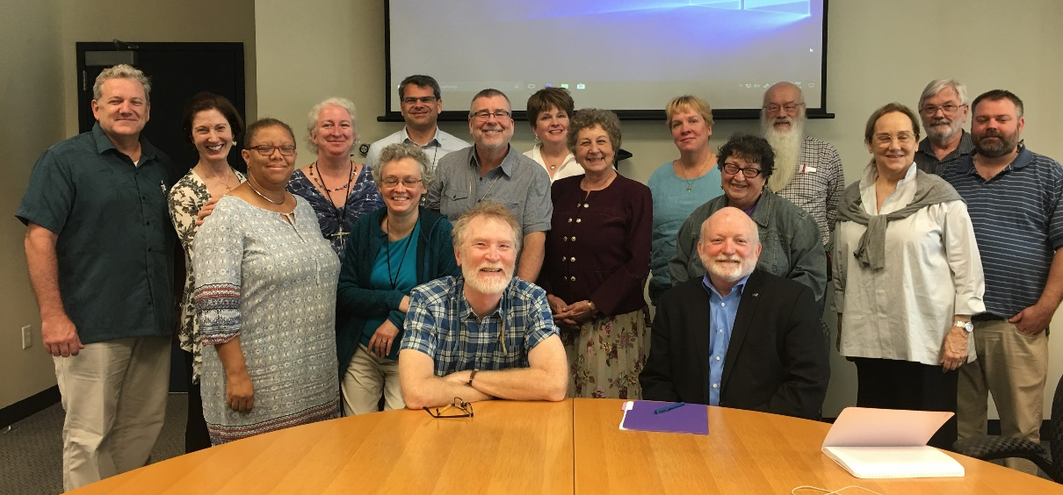
The Mission’s approach included: a) listening empathetically to the stories from the Cuban Americans in Miami and from the Cuba-Cubans in Holguin, Santiago, Guantanamo, Havana and Matanzas; b) acknowledging in prayer the 5 decades of persistent pain and grief suffered by families being separated in waves of notorious emigrations, exiles, dangerous escapes, and
being caught up in the continuing political conflicts, cultural
CCN-NA Board with Dr. Jorge Duany, Cuban American Institute, Florida International University, Miami FL¹

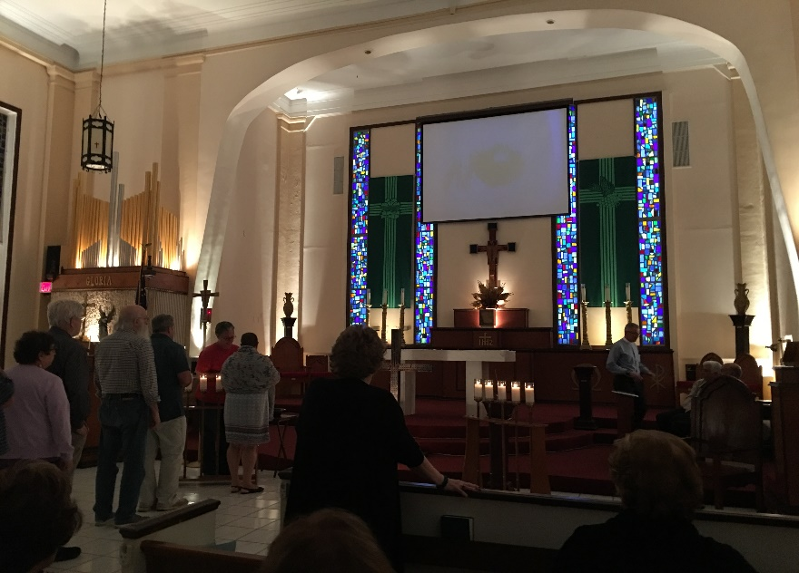
differences, and economic stresses following the Cuban Revolution’s victory on January 1, 1959; and c) praying with and for all affected by these stories, asking God’s forgiveness … not just “for them on the other side” but “for us here, and there and everywhere” … Padre, perdona ... and sensing the hope that comes from sharing God’s Love together.
Board members and pilgrims visited with and listened to leaders of the Cuban American National Foundation at their headquarters and resource center in Miami, where we gained insight into the emotional political wounds that still burn in Miami. Later at FIU, Dr. Jorge Duany updated us with a time-lined history review and discussions of the Revolution. We ended the evening with a warm welcome and dinner at Todos Los Santos
Episcopal Church in Miami, followed by a lovely
Todos Los Santos Episcopal Church in Miami, Florida
candlelight service honoring the Cross of Nails and presided over by the Rev. Alejandro Hernandez and Former Cuban Bishop Miguel Tamayo.

The next day 17 of us flew to Cuba with plans to visit the two existing CCN Partners on either end of the nation island and to plant a third Cross of Nails in Matanzas, Cuba and welcome a new world Partner into the network of CCN.

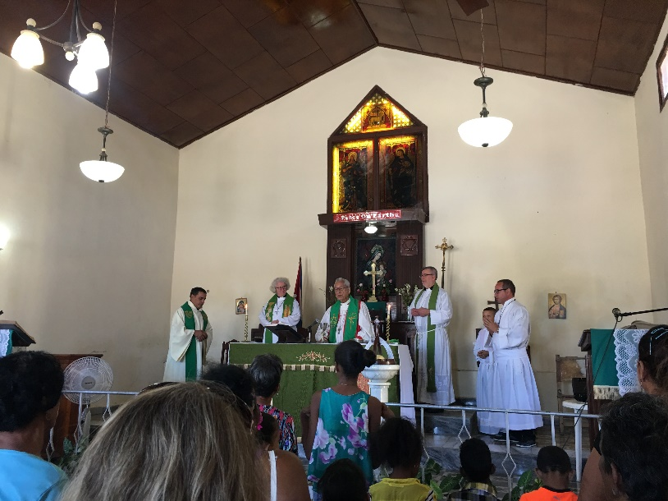
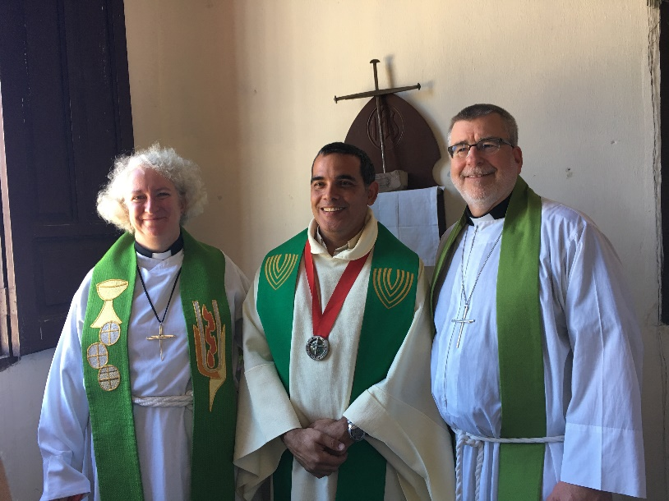
The Rev. Halbert Pons welcomed us to Santiago de Cuba in grand style with a full pig roast buffet dinner on the patio of his principal church (of six in his charge), San Lucas. The next day Sunday services were held at CCN Partner Iglesia Episcopal de Santa Maria, where Cuba’s second Cross of Nails resides. In the photo left-below, the CCN Director of Reconciliation and Peace at Coventry, England, Canon Dr. Sarah Hills, and the President of CCN-NA, The Rev. Mark Pendleton of Christ Church, Exeter, New Hampshire, flank Father Halbert with his newly gifted CCN legacy pendant from Coventry. The three priests beam with joy as Santa Maria’s Cross of Nails seems to punctuate the strengthening of international bonding in Christ between their three countries. The photo on the right: The Rt. Rev. Ulises Agϋero, (retired) Suffragan Bishop of Cuba, celebrates the Eucharist with Santa Maria’s lively congregation and choir.
Sarah, Halbert, Mark, and the Cross of Nails at Santa Maria, Santiago Bishop Agϋero celebrates at Santa Maria

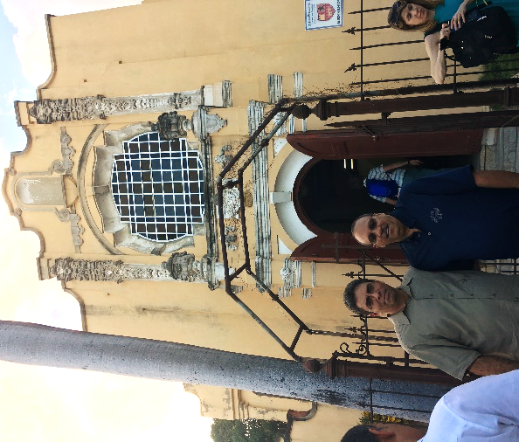
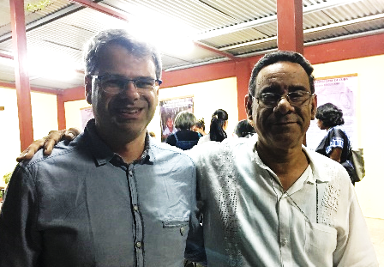
The Rev. Dr. Oliver Schuegraf, President of CCN- Germany (left), spent that same day with the Lutheran Bishop of Cuba, the Rt. Rev. Ismael Laborde (right), at the Lutheran Cathedral in Santiago de Cuba.

While in the “Oriente de Cuba” (East End of Cuba) the CCN pilgrims traveled with Bishop Agϋero and Archdeacon Father Halbert to nearby Guantanamo to visit the congregation of la Iglesia Episcopal de Todos Los Santos and its Rector, the Rev. Alfredo Nuño. An evening choral service, that included the Coventry Litany “Father Forgive,” gave thanks to God in recognition of the reactivation of formal Companionship between Todos Los Santos and St. Thomas Episcopal Church of Palm Coast, Florida within the Cuba Companionship Ministry of the Diocese of Florida. Fellow lay traveler Alfredo Rodriguez represented his home church St. Thomas (Interim Rector, The Rev. Reed Freeman) in this companionship endeavor. In the photo, Cuban Father Alfredo Nuño (left) and American Alfredo Rodriguez (right) welcome the CCN entourage to Guantanamo’s Episcopal Family on February 5, 2018.

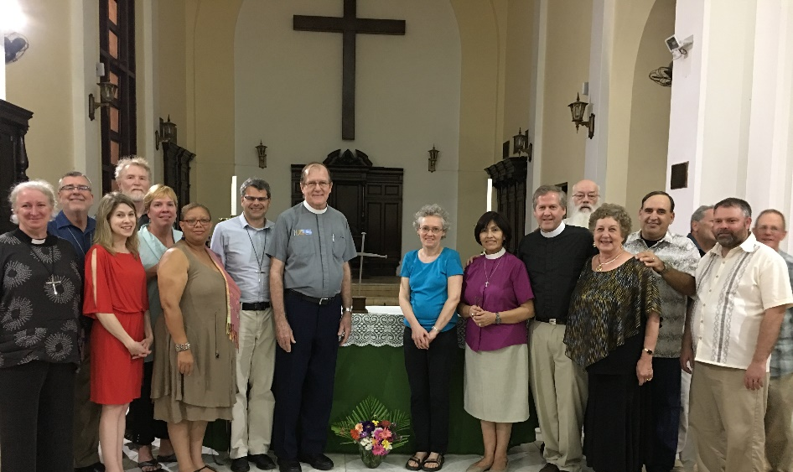
Onward the next day to the “Oeste” (West End of Cuba), we flew to Havana to pay homage to the first Cross of Nails, installed in Cuba at the Catedral Santísima Trinidad in 1989 by Rev. John Petty, Dean of Coventry Cathedral, and under the sponsorship of the Rev. Canon Arthur and Charlotte Spruill from the Diocese of Florida. Jacksonville’s St. John’s Episcopal Cathedral was the first CCN Partner in the state of Florida. It was also “companioned” with Havana’s Cathedral Church by Bishops Frank Cerveny and Emilio Hernandez under their newly created Florida-Cuba Companionship Ministry, that served as the first Episcopal bridge from the US to Cuba since the political isolation some 20 years prior. In this next photo our CCN delegation gathers around the veteran Cross of Nails on the altar at Santísima Trinidad, joined by its Dean, The Very Rev. Jose Angel Gutierrez (grey shirt), by the Diocesan Bishop of Cuba, The Rt. Rev. Dr. Griselda Delgado del Carpio (purple blouse, of course), by the also visiting Rev. Marek Zabriskie of Philadelphia (St. Thomas, Whitemarsh, black shirt, whose 15 other pilgrims visiting Cuba are not pictured here), and by the bishop’s husband The Rev. Gerardo Logildes (hand on Marilyn Peterson’s shoulder).

LASTLY, THE HIGHLIGHT OF OUR CCN MISSION!
Erin Newton (turquoise blouse next to Bishop Griselda) has been a long-term member of the Board of CCN-NA, currently serving as secretary. She hails from Pullen Memorial Baptist Church in Raleigh, North Carolina, that has maintained a long-term Companionship Ministry with the First Baptist Church of MATANZAS in that city of Cuba. With months and years of collaboration with Rev. Orestes Roca and interpreter Brother Stan Dotson of Matanzas, Erin smoothed the way for First Baptist-Matanzas to be the latest Partner in the 200+ worldwide network of the Community of the Cross of Nails. Two weeks before her trip from England, The Rev. Dr. Sarah Hills blessed the Matanzas’ cross at the altar of the Cathedral Church of St. Michael in Coventry and faithfully carried it to Cuba. On February 7, 2018, up to 300 multi-national and multi-denominational Christians packed the spirit-filled sanctuary in Matanzas to witness the “Liturgy for Receiving the Cross of Nails” and to commit themselves to work and pray for justice and reconciliation and to live in peace the Coventry Way. Rev. Hills’ homily, focused on grief, hope, and the love of God, echoing the three-pronged mission statement of CCN.
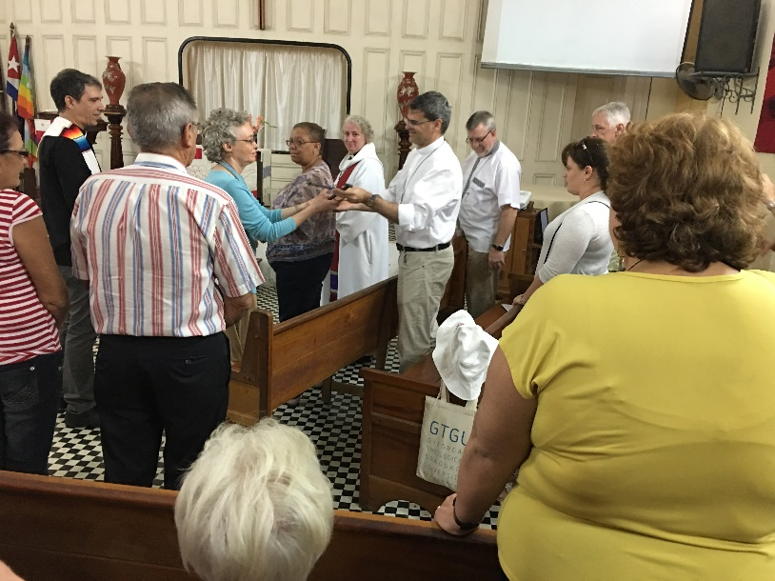
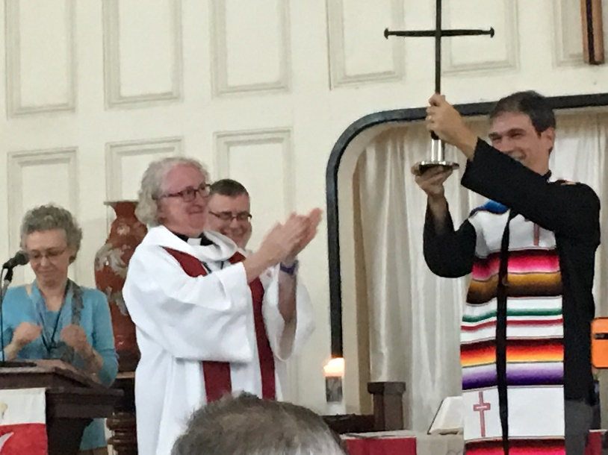
Left photo below: As Coventry’s Anglican leader of Reconciliation and Peace hands the Cross over to Father Orestes, he proudly holds the Cross of Nails up high to a cheering congregation. Right photo below: In a tender but spontaneous gesture of world peace, Pastor Orestes passes the Cross to this diverse congregation so that it could be lovingly circulated, hand by hand, to each attending witness, to touch and feel the Love of God. The Cross comes full circle as The Rev. Oliver Schuegraf of CCN-Germany hands the Cross of Nails to Erin Newton of CCN-North America, who returns it to Pastor Orestes. With joyful song and prayer, the THIRD Cross of Nails in Cuba has found its home in Matanzas!

Welcome, First Baptist Church of Matanzas, Cuba, with God’s blessings, to the global Community of the Cross of Nails!

¹First photo above (CCN-NA Board Members*), Seated: Rev. Robert T.J. Childers* Dr. Jorge Duany. First Row Standing: Petrina Pakoe of CCN-South Africa, Erin Newton*, Rev. Mark Pendleton*, Marilyn Peterson*, Kresha Warnock, Rev. Sarah Buxton-Smith*. Back Row: Rick Miessau, Terry Childers, Rev. Dr. Sarah Hills of CCN-Coventry, Rev. Dr. Oliver Schuegraf of CCN-Germany, Angela Shelley*, Leslie Pendleton, Very Rev. Gary Kriss, Rev. Jim Warnock*, Josh Molnar.

"Healing the wounds of history, learning to live with difference and celebrate diversity, and building a culture of peace."

